
Artificial intelligence
(LAB)


Submitted By:
Name: Maira
Roll No: 249
Section: BSAI-3D

Submitted To:
Sir Rasikh
Task 1: AI Timeline
The following timeline shows some important developments in Artificial Intelligence. It is arranged in chronological order and includes the major events that helped AI grow from early research into modern technology.
Year / Period | AI Milestone | Significance | Source
1950 | Turing Test | Alan Turing introduced the imitation game to explore whether a machine could show human-like conversational behaviour. | Alan Turing, Computing Machinery and Intelligence (1950). https://doi.org/10.1093/mind/LIX.236.433
1956 | Dartmouth Conference | The term Artificial Intelligence was introduced as a research field during this conference. It is considered an important starting point in AI history. | Dartmouth College, The Founding and Future of AI. https://ai.dartmouth.edu/our-story
1974–1980 | First AI Winter | AI research faced reduced funding and interest because early systems could not meet many of the high expectations. | Actuaries Institute, History of AI Winters. https://www.actuaries.asn.au/research-analysis/history-of-ai-winters
1980s | Growth of Expert Systems | Expert systems became popular. They used stored knowledge and human-written rules to solve specific problems, such as medical diagnosis. | UK Parliament, AI in the UK: Ready, Willing and Able? https://publications.parliament.uk/pa/ld201719/ldselect/ldai/100/10005.htm
2012 | AlexNet and Modern Deep Learning | AlexNet used a large image dataset and GPU computing to train a deep neural network. It showed how data and powerful computers could improve AI performance. | Krizhevsky, Sutskever and Hinton, ImageNet Classification with Deep Convolutional Neural Networks (2012). https://proceedings.neurips.cc/paper_files/paper/2012/file/c399862d3b9d6b76c8436e924a68c45b-Paper.pdf

Explanation:
This timeline shows how Artificial Intelligence developed over the years. Early research focused on machine intelligence and rule-based systems. Later, AI faced a period of reduced funding and expectations known as the AI winter.
During the 1980s, expert systems became useful for solving specific problems through written rules. In recent years, larger datasets, better algorithms and powerful computing hardware have helped modern AI systems perform more complex tasks.

Conclusion:
AI has developed through many important stages. Its progress depends not only on better algorithms but also on available data and computing power. These developments have helped AI become useful in many areas of everyday life.

====================================================================
Task 2: Rule-Based Scholarship Eligibility System

Objective
The purpose of this task is to improve a simple rule-based scholarship system by adding two extra conditions and checking its results through different test cases.

Conditions Used
The scholarship system will check the following four conditions:
- The student's score must be 70 or above.
- All required documents must be complete.
- The student's attendance must be at least 75%.
- All required information fields must be correctly filled.
For this task, I have used these conditions as simple assumptions for a sample scholarship system.

Test Cases and Expected Results
Test Case | Score | Documents Complete | Attendance | Information Fields Valid | Expected Result
1. Eligible Student | 85 | Yes | 80% | Yes | Eligible
2. Low Attendance | 80 | Yes | 70% | Yes | Not Eligible
3. Invalid Information | 90 | Yes | 85% | No | Not Eligible
4. Minimum Score Boundary | 70 | Yes | 75% | Yes | Eligible

Explanation of Test Cases
Test Case 1 – Eligible Student:
The student meets all four conditions, so the system should approve the scholarship.
Test Case 2 – Low Attendance:
The student's attendance is below 75%, so the system should reject the application even though the other conditions are satisfied.
Test Case 3 – Invalid Information:
The student meets the score, document and attendance requirements, but some information is missing or incorrect. Therefore, the application should not be approved.
Test Case 4 – Minimum Score Boundary:
The student's score is exactly 70, which meets the minimum score requirement. Attendance is also exactly 75%, and all other conditions are satisfied. Therefore, the student should be eligible.
Why These Test Cases Were Selected
I selected these four cases to check both normal and boundary situations. The first case checks a successful application, the second and third check failures of the two added conditions, and the fourth checks whether the system accepts the exact minimum score and attendance requirements.

Conclusion
This task shows how adding clear conditions can make a rule-based system more reliable. The system checks every requirement before making a decision instead of approving a student based on marks alone.

Program Output:

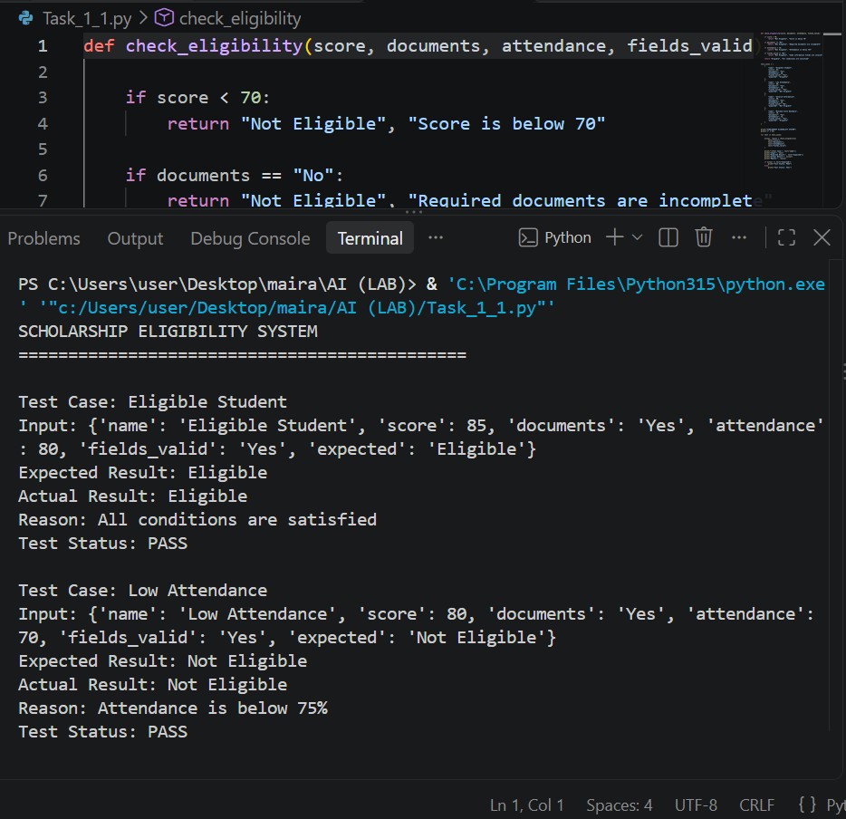
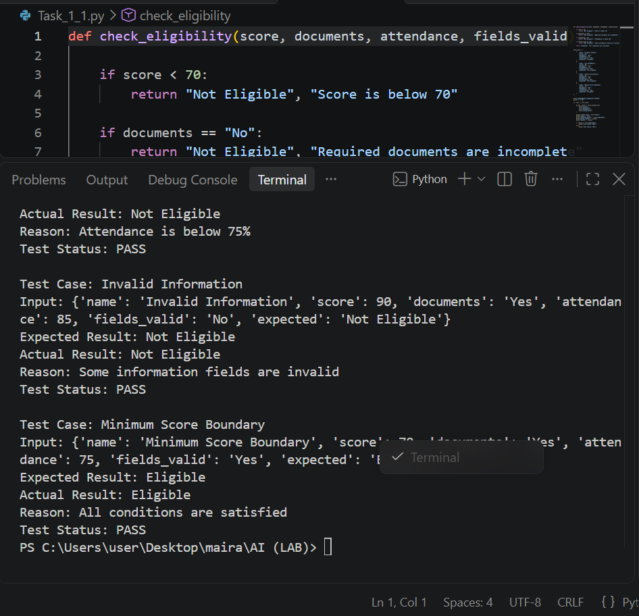

====================================================================

Task 3: Conversational Test vs General Intelligence

1. Does Passing a Conversational Test Mean an AI Has General Intelligence?
No, passing a conversational test does not automatically mean that an AI has general intelligence. A conversational test checks whether a machine can communicate in a way that seems similar to a human.
An AI may give natural and well-written answers, but this does not prove that it can understand every situation, solve different types of problems, or make correct decisions in real-life situations.
2. Applying This Idea to the Scholarship System
Consider a student asking an AI chatbot whether they qualify for a scholarship.
The chatbot may give a fluent and confident answer. However, if it ignores the attendance requirement or incomplete documents, its answer may be incorrect.
For example, a student has:
- Score: 80
- Documents: Complete
- Attendance: 60%
- Information fields: Valid
The chatbot might say that the student is eligible because their score is above 70. However, the actual rule-based system should reject the application because attendance is below 75%.
This shows that speaking confidently is not the same as following all the rules correctly.
3. What a Conversational Test Can Show
A conversational test can provide evidence about an AI's ability to:
- Understand questions and respond naturally.
- Maintain a conversation.
- Produce human-like language.
- Give relevant responses during an interaction.
4. What a Conversational Test Cannot Establish
Passing the test alone cannot establish that an AI:
- Has general intelligence.
- Always gives correct information.
- Understands every situation deeply.
- Can solve all kinds of unfamiliar problems.
- Makes reliable decisions in real-life situations.
5. An Additional Test for More Reliable Evaluation
AI should also be tested on practical tasks instead of judging it only through conversation.
For example, the scholarship system can be given different student records, including new and boundary cases. Its decisions can then be compared with the actual scholarship rules.
If the system consistently checks all conditions and gives correct results, this provides stronger evidence of its performance in that specific task

6.Final Comparison:
Conversational Test | Practical Rule-Based Test
Checks human-like communication. | Checks whether the system follows specific rules.
Focuses on conversation and responses. | Focuses on correct decisions and results.
A fluent answer may still be incorrect. | Results can be checked against fixed conditions.
Does not prove general intelligence. | Shows performance on the task being tested.

7. Limitations
A conversational test has limitations because an AI can produce human-like answers without always giving correct information. Similarly, a rule-based system can make correct decisions only within the conditions it has been programmed to check. Neither test alone proves general intelligence.

8. Conclusion
A machine that talks like a human is not necessarily intelligent in every area. Conversational ability is only one part of AI evaluation. To understand an AI system's actual performance, we should also test its accuracy, reasoning, consistency and ability to handle different tasks.
References
- Turing, A. M. (1950). Computing Machinery and Intelligence.
https://doi.org/10.1093/mind/LIX.236.433
- Jones, C. R., & Bergen, B. (2024). Does GPT-4 pass the Turing test?
https://aclanthology.org/2024.naacl-long.290/
- Stanford Encyclopedia of Philosophy. The Turing Test.
https://plato.stanford.edu/entries/turing-test/

Program Output:


